Petrochemical
Mud-Logging
www.dps-instruments.com

The process of Mud-logging involves collecting, analyzing and recording the meaningful solids, fluids, and gasses brought to the surface by the drilling fluid (mud). For the gas analysis portion of the mud-logging process, the rugged and reliable DPS Mud-logging GC System automatically samples and analyzes the gases coming out of the mud for methane and heavier hydrocarbons using a sensitive FID detector. The entire cycle time for speciation of C1 - C5 hydrocarbons is less than 2 minutes and the BTU value is automatically calculated. A 2nd FID detector is added to determine total hydrocarbons at the same time. Using a built-in air compressor, the entire system runs off one tank of hydrogen. Adding a methanizer to the FID to analyze CO2 is especially helpful for monitoring a well once you have hit pay dirt! The fully integrated Mud-logging GC Systems are small and lightweight and all DPS systems are modular for expandability, upgrades, and easy service.

Available Configurations Include:

600-C-093 - Series 600 Mud Logging GC Analyzer (FID, FID, Valve, 2m) 500-C2-093 - Companion 2 Portable Mud Logging GC Analyzer (FID,
FID, Valve, 2m)

Series 600 GC

Low Level Natural Gas Standard

FID Detector #1
Detector Temperature = 200C Gain = 4
Collector = -100V Valve = 100C
Carrier = Hydrogen @ 250 kPa Column = 4m x 1/8” 20% OV-1 Temp Program = 110C Isothermal

Companion 2 Portable GC
11/2015
Specifications may change without notice.

FID Detector #2
Detector Temperature = 200C Gain = 3
Collector = -100V Valve = 100C
Carrier = Hydrogen @ 50 kPa Column = None
4 iso-Butane 159.0 0.003 9.8 9.9 3251.9
5 n-Butane 159.7 0.003 9.9 9.9 3262.3
Peak | Component | Area | Int w/o | Int | External | Units
1 | Methane | 295.5 | 0.02 | 20.2 | 18.2 | 1010 | Heating Value of
2 | Ethane | 604.1 | 0.019 | 33.6 | 31.2 | 1769.7 | Compound
3 | Propane | 370.9 | 0.008 | 20.1 | 20.1 | 2516.1

6 n-Pentane 205.5 0.003 12.0 12.0 4008.7
0.056 105.5 101.3
Total BTU Valve
Mole Fraction

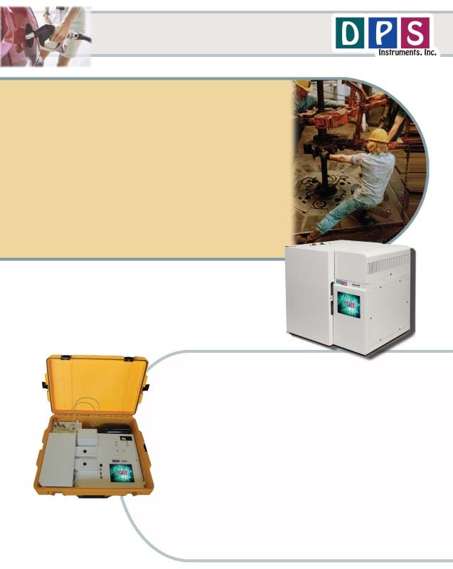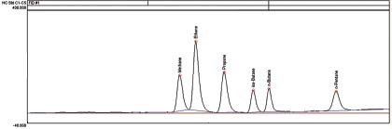Temp Program = 110C Isothermal Peak Component Area External
1 Total Hydrocarbons 271.2 5.6%

DPS MudlOgging LayOuts

COmPaniOn 2 GC
Valve Oven Gas COnneCtiOns

Rugged watertight Case

Small High Pressure Gas Cylinder

POwer COnneCtiOn with breaker and line filter
DeteCtOrs COlOr TOuChsCreen

USB & Ethernet COnneCtiOns

GC Oven
On-COlumn InjeCtOrs

Series 600 GC
DeteCtOrs FlOw ThrOugh
Oven COOling

SamPle Valve and Valve Oven
VOltage SeleCtiOn (120 Or 240VaC)

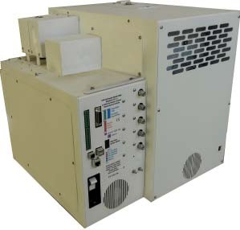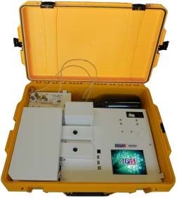USB & Ethernet COnneCtiOns

POwer COnneCtiOn with breaker and line filter

EPC Inlets

SamPle Inlet

COOling Fan

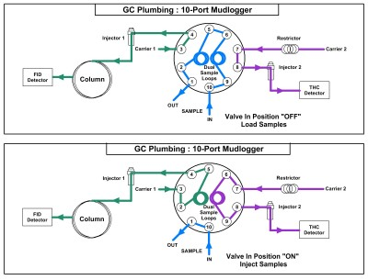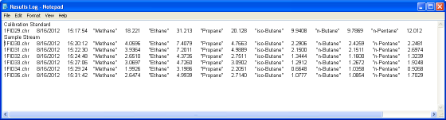Plumbing Diagram
Load: The sample is simultaneously loaded onto both sample loops, either under positive pressure, or the with the aid of a built-in Vacuum Pump. Independent carrier gases connect to each injector. A sample, or standard can always be manually injected into either Injector.
Inject: The Sample Valve is rotated to the ON position and the carrier gases sweep the components from the Sample Loop onto the analytical column and to the THC detector. For the C1-C5 hydrocarbon separation we use a 2m packed column. For the fastest cycle times the Column Oven temperature is held constant, however we use a Pressure Program Ramp to push the heavier compounds through the column faster. For the Total Hydrocarbon analysis there is no column connected to the 2nd injector and all of the hydrocarbons pass to the detector together generating a THC peak, that can be quantitated and reported.

Dual SamPle LOOP Plumbing Diagram

Results LOg

The sample results can be stored and reported in various ways. One convenient method of storing a vast amount of sample data is in a Results Log. A separate Results Log can be generated for each detector. In the example above the first analysis is a low level calibration standard. The subsequent analyses are from a sample stream coming from the well. The BTU value is reported next to each compound. The sample results can be stored on the hard drive of the computer inside the GC, or on an external computer via an ethernet connection.

