*Environmental*

*Soil Gas Analyzers*

[*www.dps-instruments.com*](http://www.dps-instruments.com/)

Millions of liters of chlorinated solvents used in industry over the years have spilled, polluting our air, soil, rivers, lakes, and streams. Environmentally conscious legislation has been passed in many parts of the world to limit future spills, clean up existing polluted sites, and lessen the overall risk to ourselves and to our children.

Looking towards a greener world, DPS has configured a Companion 2 Portable Soil Gas GC Analyzer, enabling analysis in the field for Type 1 hazardous substances (11 compounds) specified in the Soil Contamination Countermeasures Law in Japan. The DPS Soil Gas GC has a built-in Sample Concentrator with Trap and dry purge functions for low ppb level analysis of these 11 compounds, and the newly added compound, Chloroethylene. The PID is very sensitive to aromatics and alkenes, and the BCD is ultra-sensitive to chlorinated and brominated compounds. This combination of detectors covers all of the compounds in the Countermeasures Law, and more. All DPS GC systems are small, lightweight and modular for expandability, upgrades, and easy service.

*Available Configurations Include:*

500-C2-013 - Companion 2 Portable Soil Gas GC Analyzer (PID, BCD, 30m)

500-C2-019 - Companion 2 Portable Low-Level GC Analyzer (PID, BCD, 30m, and Sample Concentrator)

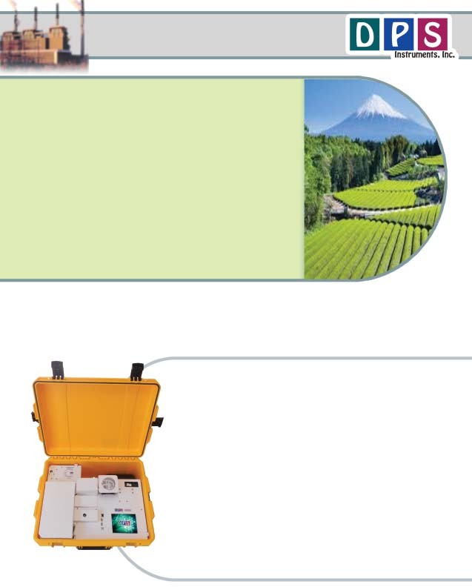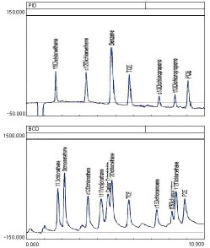

Companion 2 Portable GC (With Air Concentrator)

8/2018

Specifications may change without notice.

1 ppm Hazardous Substances

PID Detector

Detector Temperature = 175C High Voltage = 800V

Gain = 6 Collector = -100V

Carrier = Helium @ 60 kPa = 10mls/min Column = 30m x 0.53 MXT-502.2

Temperature Program = 50C (hold 3 min) to 120C @ 10C/min

|  |  |  |  |
| --- | --- | --- | --- |
| Peak | Component | Area | ppm |
| 1 | 1,1-Dichelroethene | 195.6 | 1 |
| 2 | cis-1,2,-Dichloroethene | 295.2 | 1 |
| 3 | Benzene | 672.7 | 1 |
| 4 | Trichloroethylene | 322.4 | 1 |
| 5 | cis-1,3-Dichloropropene | 90.4 | 1 |
| 6 | trans-1,3-Dichloropropene | 106.2 | 1 |
| 7 | Tetrachloroethylene | 270.6 | 1 |

BCD Detector

Detector Temperature = 175C Cell Temperature = 800C

Gain = 2 Collector = -100V

|  |  |  |  |
| --- | --- | --- | --- |
| Peak | Component | Area | ppm |
| 1 | 1,1-Dichelroethene | 5598.7 | 1 |
| 2 | Dichloromethane | 7122.3 | 1 |
| 3 | cis-1,2,-Dichloroethene | 5880.7 | 1 |
| 4 | 1,1,1-Trichloroethane | 5615.1 | 1 |
| 5 | Carbon Tetrachloride | 3126.5 | 1 |
| 6 | 1,2-Dichloroethane | 4668.1 | 1 |
| 7 | Trichloroethylene | 5903.7 | 1 |
| 8 | cis-1,3-Dichloropropene | 3056.6 | 1 |
| 9 | trans-1,3-Dichloropropene | 1262.2 | 1 |
| 10 | 1,1,2-Trichloroethene | 5295.4 | 1 |
| 11 | Tetrachloroethylene | 4838.6 | 1 |

# DPS COmPaniOn 2 SOil Gas GC LayOut

**Rugged watertight Case**

**Gas COnneCtiOns**

**TraP & COOling Fan**

**Small High Pressure Gas Cylinder**

**POwer COnneCtiOn with breaker and line filter**

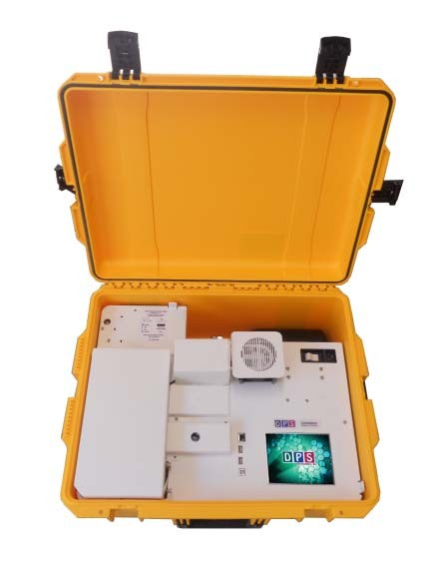

**Valve Oven**

**GC Oven**

**BCD DeteCtOr PID DeteCtOr**

**COlOr TOuChsCreen**

**USB & Ethernet COnneCtiOns**

**Heated On-COlumn InjeCtOr**

# Plumbing Diagram

Sample Concentrator: The Air Sample Concentrator is built right into the Companion 2 GC Chassis to provide both a compact portable sample concentrator and a shortest possible sample path. The valve and sample lines are heated creating a inert sample path.

Load Sample: The vacuum pump draws the sample from the inlet through the Trap and then to the flow controller and pump to limit any possible cross contamination between samples. The entire sequence of the Air Sample Concentrator is automated through the Timeline of the DPS Control Software for the analysis of one sample at a time, or the system can be set up to run unattended 24/7, collecting and analyzing samples every hour, or so. A dry purge option can be added to eliminate extra water from the sample if needed.

Inject Sample: The carrier gas sweeps the components from the trap to the analytical column. The entire sample path is heated to facilitate a smooth transfer of components to the analytical column and to limit any potential carry-over from high concentation samples.

**Built-in Air COnCentratOr Plumbing Diagram**

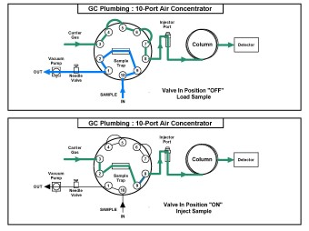

# Results, Data & COnnCetivity

Results: In this unique plumbing configuration, which utilizes a precise sample flow path and precision metering, so you get the same peak areas on the chromatogram from run to run. Both detectors are stable, rugged, and reliable.

Data and Connectivity: The built-in computer is used to collect and store the data. Data can also be copied to a USB Stick to transfer to another computer. Data can be transferred from the built-in computer to another computer on the LAN through the Ethernet port using standard Windows protocols. Or, we can use a USB cable to connect the GC to the remote computer where the data can be collected and stored on that hard drive.

**DPS SOil Gas Data Summary**

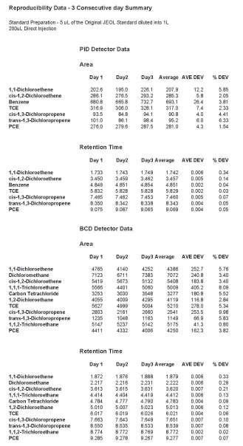

**Results are RePrOduCible Day after Day**