Environmental
VOC´s in Air Analyzers
www.dps-instruments.com

When you need the lowest level air analyses possible count on the Air Analyzers from DPS Instruments. All of our Air Analyzers include detectors tuned to their highest sensitivity and the largest dynamic range. For your convenience, we build the Air Concentrator right into the system, which includes an electronically controlled vacuum pump with a flow controller for precise and reproducible air sampling, microelectronic sampling valve, and adsorbent trap. The Series 600 GC is ideal for analyses in the lab, or use the Portable Companion 2 GC Systems for analyses right where the samples are taken. Common configurations include a FID for hydrocarbons, PID for aromatics such as Benzene, and the ultra-sensitive BCD for chlorinated compounds. A combination of detectors covers most environmental methods. An Optional Thermal Desorber can be added for sorbent Tubes collected offline. The fast heating and rapid cooling column oven in every DPS GC vastly increases your sample throughput. The fully integrated Air GC Analyzer Systems are small and lightweight and all DPS systems are modular for expandability, upgrades, and easy service.

Available Configurations Include:

600-C-022 - Series 600 VOC´s GC Analyzer (FID, FID, Air Concentrator, 2 x30m)
500-C2-022 - Companion 2 VOC´s GC Analyzer (FID, FID, Air Concentrator, 2 x 30m)

Series 600 GC

BTEX with Air Concentrator - 10 ppb

Peak Component
- Benzene
9/2021
Specifications may change without notice.
- Trichloroethylene
- Toluene
- Tetrachloroethylene
- Chlorobenzene
- Ethylbenzene
- M-Xylene
- O-Xylene
FID Detector
Detector Temperature = 200C Gain = 6
Collector = -100V
Carrier = Hydrogen @ 40 kPa Column = 30m x 0.53 MXT-624 PLOT
Temp Program = 60C (hold 9 Min) to 120C @ 10C/min

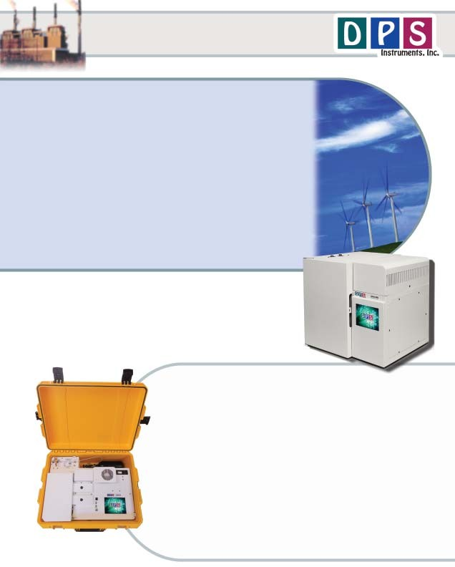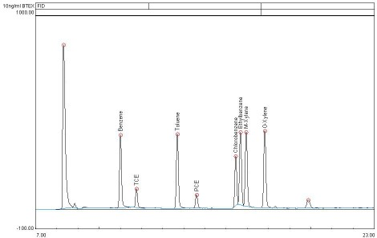

1

Companion 2 Portable GC (with Air Concentrator)

DPS VOC GC LayOuts
COmPaniOn 2 GC

Gas COnneCtiOns Valve Oven
Rugged watertight Case

Small High Pressure Gas Cylinder
TraP & COOling Fan POwer COnneCtiOn
with breaker and line filter
FID DeteCtOrs

COlOr TOuChsCreen

GC Oven
USB & Ethernet COnneCtiOns
On-COlumn InjeCtOr

Series 600 GC

DeteCtOr FlOw ThrOugh

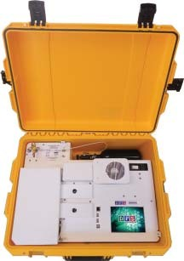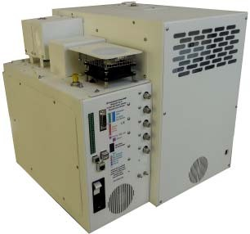SamPle Valve and Valve Oven

TraP & COOling Fan FlOw COntrOller
USB & Ethernet COnneCtiOns
POwer COnneCtiOn with breaker and line filter

EPC Inlets
Oven COOling

VOltage SeleCtiOn (120 Or 240VaC)

COOling Fan

Plumbing Diagram

Air Concentrator: The Air Sample Concentrator is built right into the GC Chassis to provide both a compact portable sample concentrator and the shortest possible sample path. The valve and sample lines are heated creating a inert sample path. The Sample Flow Controller precisely meters the amount of sample loading on the Trap.
Load Air Sample: The vacuum pump draws the sample from the inlet through the Trap and then to the flow controller and pump to limit any possible cross contamination between samples. The entire sequence of the Air Sample Concentrator is automated through the Timeline of the DPS Control Software for the analysis of one sample, or the system can be set up to run unattended 24/7, collecting and analyzing samples every hour, or so.
Inject Trap Sample: The carrier gas sweeps the components from the trap to the analytical column.
Tube Sample: The carrier gas sweeps the components from the Thermal

Desorber Tube to the analytical column.
Air COnCentratOr + Thermal DesOrber Plumbing Diagram

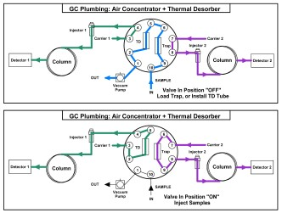

Results, Data & COnnCetivity

Results: The Results can be saved for each sample, or they can be printed, or they can be tabulated into a .LOG file, when you are collecting a vast amount of data over a long time period. The format of the. LOG file is text, so it can be opened by any word processing program.
Data and Connectivity: The built-in computer is used to collect and store the data. Data can also be copied to a USB Stick to transfer to another computer. Data can be transferred from the built-in computer to another computer on the LAN through the Ethernet port using standard Windows protocols. Or, we can use a USB cable to connect the GC to the remote computer where the data can be collected and stored on that hard drive.

